# CHAPTER 1

# INTRODUCTION

# INTRODUCTION

Poverty is the main obstacle of development in developing countries; government organization designs various policies to recover from it. To apply those policies, it is necessary to identify poor areas. And to identify poor areas various methodologies are used like household survey, GDP (gross domestic product) etc. But those traditional methodologies have many limitations in case of time, effort, and expensive. The household survey requires more time, more efforts and money. To do the household survey it needs to reach each doorstep in the country, collect all the data of each house, organize it, analyze it and then make policies accordingly, this lengthy process slows down the rate of development in the country. Earlier GDP statistical analysis was used to track socioeconomic activities. But it had many limitations as it does not differentiate costs from benefit and not distinguishes sustainable practice from unsustainable ones. Also, the GDP gives less accuracy. Data availability is consequently scarce and it is not updated regularly. To overcome these limitations poverty prediction using satellite images with machine learning can be applied. Satellite images are freely available for research purpose and are up to date. And machine learning methods give optimum accuracy and require less time for processing. Nighttime data already used to estimate the population, coal consumption, electricity consumption in a country. Also, the daytime data is used for object detection in images like buildings, structure of building, roofs, roads, rivers, plants and many more. It also has the potential to predict poverty in less time. So that policies can be applied in time to the areas it needed, which will increase the rate of development in the country. In this paper combining satellite images of nighttime and daytime with machine learning methods, Regression and CNN are used to poverty area detection. DHS (demographic health survey) data used to train the machine learning model with remote sensing data. And then use that model to predict poverty using only satellite images. Now a day’s machine learning technology is growing rapidly with strong algorithms and less time complexities, therefore, it can be used to solve these socioeconomic problems. Also, the electronics technology is developing rapidly so that more accurate remote sensing data is easily available. Thus, combining Machine learning and remote sensing data to predict poverty will give more accuracy than now in the future

**RELATED WORK**

Earlier researchers have done work on poverty prediction using various methodologies. In 2007 Christopher D. Elvidge who is a member of Earth Observation Group shows that satellite data has a potential to detect poverty. For this, they represented observed radiances from nighttime lights versus population count for three cities. Their observation shows that there is dim light or no light in the poor area and bright light in a developed area which opens the door for further researches. In 2009 students of IIT demonstrated that there is a sharp increase in the amount of impervious land, decrease in open spaces, shrinking of fertile agricultural lands, reductions in vegetation cover, decrease in water bodies and its effect on urban poverty.

Pre-trained model is used to extract feature from daytime satellite image in their experiment of resolution 1920×1920 at a zoom level of 16 and CNN is used to train the model. After that Neal Jean used 3 methods OLS, Lasso and Ridge with R2 - 0.327, 0.339, 0.331 respectively. He uses census data to train these regression models.

# CHAPTER 2

# LITERATURE SURVEY

# LITERATURE SURVEY

# Literature Survey: -

# Reliable information for predicting poverty remain unavailable in the world now. This is due to the dearth of data regarding the social, environment, and health and livelihood issues. Rich countries have large amount of data to measure the poverty, but developing countries lack with spatially sparse and infrequently collected data due to high cost of surveys. Poverty, a major agitation, has also been mentioned as the first of seventeen Sustainable Development Goal by the United Nations to get removed. In the earlier times, the primary source of data to measure the poverty is the ground level survey such as household consumption and wealth, which is time consuming, expensive and inexact source of data. In the context of Ground Level Surveys, LSMS (Living Standard Measurement Survey) was initially used. LSMS survey is used to calculate the Household Expenditure. Since the scope of LSMS survey is very small, it does not provide the wealth of information. Using mobile data, digital footprints is an attempt to predict the poverty. To track the progress of the Sustainable Development Goals and target the intermediate information requires persistent, versant on economic, ecosystem and livelihood conditions. Remote Sensing data such as satellite imagery is becoming easily available and inexpensive, the data gathered from the satellite images is highly structured. The goal of this is to minimize the data gap using publicly available data source, for this a CNN is to be trained to estimate the poverty level using satellite imagery. These Machine Learning approaches not only estimate the poverty level for a single year but also establishes the relationship between several years. The foremost goal of the study is to spontaneously learn visual features in satellite images that indicates the poverty in a region. The techniques also suggest that predicting poverty from multiple developmental parameters is more reliable than predicting poverty from a single parameter. Satellite Imagery is used for Object Identification, Image Segmentation and Labelling of an Image. High resolution Google Static Maps Imagery is used, but since Google Static is exclusive, a low-resolution image can be used. Publicly available satellite imagery can be taken from the United States Gov. Landsat 7 satellite program. These techniques use a Convolutional Neural Network which is pretrained on one of the datasets and then train the network to predict the nightlight light intensity analogous to input daytime satellite imagery. In the end, a model is trained to directly estimate the local per capita outcomes from daytime image features. The features learned in one model can be used for some other model. To predict the location of the center of the place as well as latitude and longitude, a Google Geocoding API is used. Multi-task learning involves learning multiple tasks exclusively while determining the similarities and differences among the tasks. The suitable input to a model is a 1920*1920 sized image of a region. Nightlights serve as a good proxy for predicting the wealth. Raw satellite images are used for extracting the socioeconomic indicator. The transfer learning approach not only predict the nightlight intensity but also helps in mapping poverty.

# The goal of transfer learning is to transfer the knowledge to the target problem of predicting nighttime light intensity from daytime satellite imagery. Per capita consumption cannot be estimated as nightlights have difficulty in distinguishing between poor, densely populated, and wealthy and sparsely populated areas. Predicting the poverty can also be done by using the multi-Task learning which involves learning different types of tasks simultaneously and also evaluating the similarities and differences between them. In Multi-Task Fully Convolutional Model, the Convolutional block comprises of Convolutional Layer, A Batch Normalization Layer. The accuracy of the model is determined by the calculating the Pearson’s Correlation Coefficient i.e., r2. The relationship between the household data and remote sensed data differs at the community level. The Wikipedia Model learn associations with poverty and outperforms nightlights only. The Recurrent Network can be placed on the top of the Convolutional Neural Network so that prediction across years can be determined and poverty forecasting. The basic understanding developed by reviewing the survey is that these satellite images can be successfully used in order to predict the poverty index of the particular region. This approach gave better understanding in analyzing the poverty issues in several African countries.

# 2.1 PROPOSED APPROACH

# Our idea is to predict the poverty index of a particular region in India. It is inspired by the successful use of deep learning approaches for poverty prediction in several African countries as appreciated in literature. With this paper, we want to estimate the correlation of poverty predicted from satellite images and wealth score obtained from DHS survey data of India. On successful implementation, the result obtained will be compared with the result obtained from ground-level surveys. Firstly, the model takes Demographic and Health Survey Data i.e. Household Data (dataset has record for each individual) and Geographical Data (Health Data, Infrastructure such as roads, buildings linked with DHS Data). It further generates information of the cluster and Household Data containing the wealth score, cluster wealth, latitude and longitude. This raw survey data is then used to produce more refined clusters. Then the extracted cluster data is processed to generate image coordinates. The image coordinates are generated in order to download the images of size 400 * 400 pixels using HERE Maps API which is later resized of size of 299 * 299 pixels. Similarly, the nightlight image is downloaded from the DMSP-OLS of size 43201 x 16801 pixels. The downloaded daylight images are then divided into 3 classes based on nightlight intensities of identical regions acquired from nightlight image. These 3 classes are Low [0-7 nightlight intensity], Medium [8-15 nightlight intensity] and High [16-63 nightlight intensity].

# Used pre-trained model of Inception V3 is trained on ImageNet Database [16] with thousands of images. The network is covered with 48 layers and classified into 1000 image categories. The size of image in the network is 299 x 299 pixels. The Inception code uses TF-slim, which seems to be a kind of abstraction library over Tensor Flow [15]. As a result, model has learned rich feature representation for a wider range of images. The Parent Layers in the Model are Basic Conv2d and Inception A/ Batch Conv2d. The sub-layers include Conv-2d and Batch-Norm 2d. The Model includes Total Number of Parameters, Number of Trainable Parameter and Non-Trainable Parameter. We used PyTorch library to build our Convolutional Neural Network model pretrained which is a pre-trained network of Inception V3. The daylight satellite images are taken as input to this pretrained model to extract the features for further classification. Class labels obtained from nightlight regions of image are used in final classification layer for classification of daylight images. The DHS data is used in regression model for measuring correlation between predicted values from model and actual assets value.

# CHAPTER 3

# SYSTEM ANALYSIS

# System Analysis

# 3.1 Existing System:

# Currently, poverty is formally calculated by numerous philanthropic agencies including the World Bank. One of the reasons why data on poverty is sparse in the developing world is because it is infrequently collected due to the high cost associated with on-the-ground surveys. Only after this step does the country realize where it stands with respect to the income levels.

# 3.1.1 Disadvantages:

# The current challenge in this domain is that agencies across the world who predict income levels take a huge amount of time to do the same. Once done this topic is not raised until the next decennial census comes up. Not only does it take a big chunk of time but also staggering amounts of money is invested into these kinds of projects. This is a real headache for agencies and governments all around the world.

# 3.2 Proposed System:

# Recent advancements in deep learning present an exciting opportunity for application to poverty prediction. More specifically, both daytime and nighttime satellite imagery of regions can be used to estimate poverty in certain regions. Deep learning has been a main factor behind recent breakthroughs in numerous computer vision tasks such as image classification, segmentation, and object detection. In this project, we test the hypothesis that deep learning can leverage satellite imagery to reliably predict the poverty level of a region. We assemble a dataset of 88,386 images from 44,193 cities spanning Africa, South America, Asia, Europe, and the Caribbean. For each city, we obtain a daytime satellite image, a nighttime satellite image, and the city’s wealth index. I then train Recurrent neural networks (RNNs) to predict a city’s wealth index, given a satellite image.

# 3.2.1 Advantages:

# High accuracy

# High efficiency

# Fast implementation

# Great response

# 3.3 System Specifications:

**Software Requirements**

Functional requirements for a secure cloud storage service are straightforward: The service should be able to store the user’s data; The data should be accessible through any devices connected to the Internet; The service should be capable to synchronize the user’s data between multiple devices (notebooks, smart phones,etc.); The service should preserve all historical changes(versioning);

Data should be shareable with other users; The service should support SSO;and

The service should be interoperable with other cloud storage services, enabling data migration from one CSP to another.

**Operating System** : Windows Family

Front End : Anaconda IDE

Backend : SQL

Language : Python 3.8

# Hardware Requirements:

RAM - 4 GB

Hard Disk - 500 GB

Processor - i3

# 3.4 System Architecture:

Software design sits at the technical kernel of the software engineering process and is applied regard less of the development paradigm and area of application. Design is the first step in the development phase for any engineered product or system. The designer’s goal is to produce a model or representation of an entity that will later be built. Beginning, once system requirement has been specified and analyzed, system design is the first of the three technical activities-design, code and test that is required to build and verify software.

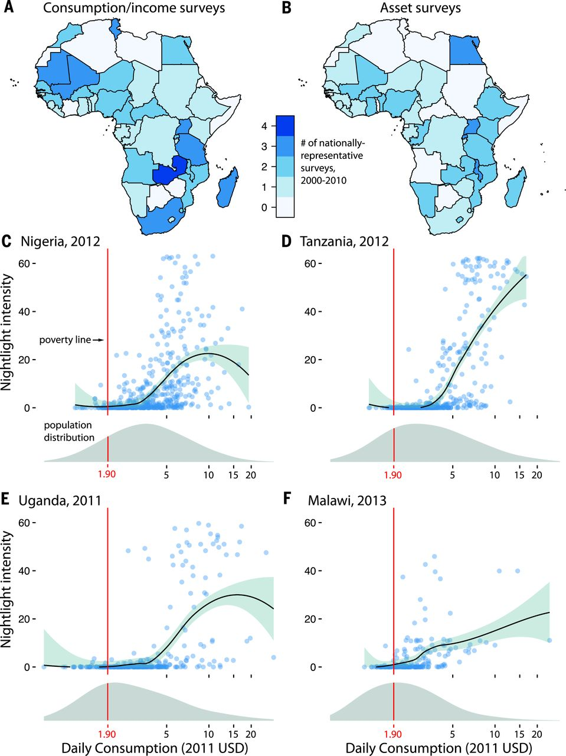

**METHODOLOGY:**

# Construction

# Construction of light to wealth index relationship • Rwanda country is divided into 492 clusters along with latitude and longitude which is then joined with DHS data. DHS data contains latitude, longitude, cluster number, wealth index, and many more parameters. Then both the cluster location and DHS data joined together on latitude and longitude.

# In this step, each cluster is assigned with some value of wealth index. • In next step, night time satellite image is processed and statistics parameter of the light index are calculated cluster’s latitude and longitude wise. All these statistics parameters like minimum value from all intensity value in a satellite image, standard deviation value, mean value, median value, and mode value is stored cluster wise in a file. • In the final step above two relational tables is joined on cluster’s value which will give cluster number, wealth index and statistics parameter of light intensity. • For daytime satellite images also same steps are done.

# B. Regression

# Multiple features from image mean, median, mode, standard deviation, and max are used to predict the wealth index at that particular cluster, therefore ridge regression model is trained to perfectly fit and to overcome the limitation of over fitting the training set. • K-fold is used to split the training and testing data into splits of 10. • Label wealth index is used with five features.

# C. ImageNet

# Like nighttime satellite image’s feature, features of daytime satellite image are also calculated using the pre-trained model called ImageNet. By with total 4096 features are retrieved for each cluster [10].

# D. CNN

# By using daytime features extracted through ImageNet to predict wealth gives less accuracy and R2(regression coefficient) is below 0.5. To overcome these daytime features are trained again using transfer learning. • There are 5 nightlight features (min_, max_, std_, median_, mean_) calculated from night time satellite image of Rwanda with its latitude and longitude. • And 4096 daytime features (CNN features) calculated from daytime images with latitude and longitude. • Then daytime images divided into 3 class of light intensity low, medium and high using the night light features of corresponding latitude and longitude. • After training the CNN model night time intensity is predicted first using daytime features of images in transfer learning. • And then the wealth index is predicted through night time features

# 

# CHAPTER 4

# IMPLEMENTATION

# Implementation

# 4.1 Software Environment:

# 4.1.1 Python Technology:

# What is Python :-

Below are some facts about Python. Python is currently the most widely used multi-purpose, high-level programming language.

Python allows programming in Object-Oriented and Procedural paradigms. Python programs generally are smaller than other programming languages like Java. Programmers have to type relatively less and indentation requirement of the language, makes them readable all the time.

Python language is being used by almost all tech-giant companies like – Google, Amazon, Facebook, Instagram, Dropbox, Uber… etc. The biggest strength of Python is huge collection of standard library which can be used for the following –

* [Machine Learning](https://www.geeksforgeeks.org/machine-learning/)
* GUI Applications (like [Kivy](https://www.geeksforgeeks.org/kivy-tutorial/), Tkinter, PyQt etc. )
* Web frameworks like [Django](https://www.geeksforgeeks.org/django-tutorial/) (used by YouTube, Instagram, Dropbox)
* Image processing (like [OpenCV](https://www.geeksforgeeks.org/opencv-python-tutorial/), Pillow)
* Web scraping (like Scrapy, BeautifulSoup, Selenium)
* Test frameworks
* Multimedia

### **Advantages of Python :-**

Let’s see how Python dominates over other languages.

#### **1. Extensive Libraries**

Python downloads with an extensive library and it contain code for various purposes like regular expressions, documentation-generation, unit-testing, web browsers, threading, databases, CGI, email, image manipulation, and more. So, we don’t have to write the complete code for that manually.

#### **2. Extensible**

As we have seen earlier, Python can be**extended to other languages**. You can write some of your code in languages like C++ or C. This comes in handy, especially in projects.

#### **3. Embeddable**

Complimentary to extensibility, Python is embeddable as well. You can put your Python code in your source code of a different language, like C++. This lets us add **scripting capabilities** to our code in the other language.

#### **4. Improved Productivity**

The language’s simplicity and extensive libraries render programmers**more productive** than languages like Java and C++ do. Also, the fact that you need to write less and get more things done.

#### **5. IOT Opportunities**

Since Python forms the basis of new platforms like Raspberry Pi, it finds the future bright for the Internet Of Things. This is a way to connect the language with the real world.

#### **6. Simple and Easy**

When working with Java, you may have to create a class to print **‘Hello World’**. But in Python, just a print statement will do. It is also quite **easy to learn**,**understand**, and **code**. This is why when people pick up Python, they have a hard time adjusting to other more verbose languages like Java.

#### **7. Readable**

Because it is not such a verbose language, reading Python is much like reading English. This is the reason why it is so easy to learn, understand, and code. It also does not need curly braces to define blocks, and **indentation is mandatory**. These further aids the readability of the code.

#### **8. Object-Oriented**

This language supports both the **procedural and object-oriented** programming paradigms. While functions help us with code reusability, classes and objects let us model the real world. A class allows the **encapsulation of data** and functions into one.

#### **9. Free and Open-Source**

Like we said earlier, Python is **freely available**. But not only can you [**download Python**](https://data-flair.training/blogs/install-python-windows/) for free, but you can also download its source code, make changes to it, and even distribute it. It downloads with an extensive collection of libraries to help you with your tasks.

#### **10. Portable**

When you code your project in a language like C++, you may need to make some changes to it if you want to run it on another platform. But it isn’t the same with Python. Here, you need to**code only once**, and you can run it anywhere. This is called **Write Once Run Anywhere (WORA)**. However, you need to be careful enough not to include any system-dependent features.

#### **11. Interpreted**

Lastly, we will say that it is an interpreted language. Since statements are executed one by one, **debugging is easier** than in compiled languages.

### **Advantages of Python Over Other Languages**

#### **1. Less Coding**

Almost all of the tasks done in Python requires less coding when the same task is done in other languages. Python also has an awesome standard library support, so you don’t have to search for any third-party libraries to get your job done. This is the reason that many people suggest learning Python to beginners.

#### **2. Affordable**

Python is free therefore individuals, small companies or big organizations can leverage the free available resources to build applications. Python is popular and widely used so it gives you better community support. **The 2019 GitHub annual survey showed us that Python has overtaken Java in the most popular programming language category.**

#### **3. Python is for Everyone**

Python code can run on any machine whether it is Linux, Mac or Windows. Programmers need to learn different languages for different jobs but with Python, you can professionally build web apps, perform data analysis and [**machine learning**](https://data-flair.training/blogs/machine-learning-tutorials-home/), automate things, do web scraping and also build games and powerful visualizations. It is an all-rounder programming language.

**Disadvantages of Python**

So far, we’ve seen why Python is a great choice for your project. But if you choose it, you should be aware of its consequences as well. Let’s now see the downsides of choosing Python over another language.

#### **1. Speed Limitations**

We have seen that Python code is executed line by line. But since [Python](https://www.python.org/) is interpreted, it often results in **slow execution**. This, however, isn’t a problem unless speed is a focal point for the project. In other words, unless high speed is a requirement, the benefits offered by Python are enough to distract us from its speed limitations.

#### **2. Weak in Mobile Computing and Browsers**

While it serves as an excellent server-side language, Python is much rarely seen on the **client-side**. Besides that, it is rarely ever used to implement smartphone-based applications. One such application is called **Carbon Nelle**. The reason it is not so famous despite the existence of Brython is that it isn’t that secure.

#### **3. Design Restrictions**

As you know, Python is **dynamically-typed**. This means that you don’t need to declare the type of variable while writing the code. It uses **duck-typing**. But wait, what’s that? Well, it just means that if it looks like a duck, it must be a duck. While this is easy on the programmers during coding, it can**raise run-time errors**.

#### **4. Underdeveloped Database Access Layers**

Compared to more widely used technologies like **JDBC (Java Database Connectivity)**and**ODBC (Open Database Connectivity)**, Python’s database access layers are a bit underdeveloped. Consequently, it is less often applied in huge enterprises.

#### **5. Simple**

No, we’re not kidding. Python’s simplicity can indeed be a problem. Take my example. I don’t do Java, I’m more of a Python person. To me, its syntax is so simple that the verbosity of Java code seems unnecessary.

**4.1.2 History of Python : -**

What do the alphabet and the programming language Python have in common? Right, both start with ABC. If we are talking about ABC in the Python context, it's clear that the programming language ABC is meant. ABC is a general-purpose programming language and programming environment, which had been developed in the Netherlands, Amsterdam, at the CWI (Centrum Wiskunde &Informatica). The greatest achievement of ABC was to influence the design of Python.Python was conceptualized in the late 1980s. Guido van Rossum worked that time in a project at the CWI, called Amoeba, a distributed operating system. In an interview with Bill Venners1, Guido van Rossum said: "In the early 1980s, I worked as an implementer on a team building a language called ABC at Centrum voor Wiskunde en Informatica (CWI). I don't know how well people know ABC's influence on Python. I try to mention ABC's influence because I'm indebted to everything I learned during that project and to the people who worked on it."Later on in the same Interview, Guido van Rossum continued: "I remembered all my experience and some of my frustration with ABC. I decided to try to design a simple scripting language that possessed some of ABC's better properties, but without its problems. So I started typing. I created a simple virtual machine, a simple parser, and a simple runtime. I made my own version of the various ABC parts that I liked. I created a basic syntax, used indentation for statement grouping instead of curly braces or begin-end blocks, and developed a small number of powerful data types: a hash table (or dictionary, as we call it), a list, strings, and numbers."

**4.2 MACHINE LEARNING**

**What is Machine Learning: -**

Before we take a look at the details of various machine learning methods, let's start by looking at what machine learning is, and what it isn't. Machine learning is often categorized as a subfield of artificial intelligence, but I find that categorization can often be misleading at first brush. The study of machine learning certainly arose from research in this context, but in the data science application of machine learning methods, it's more helpful to think of machine learning as a means of building models of data.

Fundamentally, machine learning involves building mathematical models to help understand data. "Learning" enters the fray when we give these models tunable parameters that can be adapted to observed data; in this way the program can be considered to be "learning" from the data. Once these models have been fit to previously seen data, they can be used to predict and understand aspects of newly observed data. I'll leave to the reader the more philosophical digression regarding the extent to which this type of mathematical, model-based "learning" is similar to the "learning" exhibited by the human brain. Understanding the problem setting in machine learning is essential to using these tools effectively, and so we will start with some broad categorizations of the types of approaches we'll discuss here.

**Categories Of Machine Learning: -**

At the most fundamental level, machine learning can be categorized into two main types: supervised learning and unsupervised learning. Supervised learning involves somehow modeling the relationship between measured features of data and some label associated with the data; once this model is determined, it can be used to apply labels to new, unknown data. This is further subdivided into classification tasks and regression tasks: in classification, the labels are discrete categories, while in regression, the labels are continuous quantities. We will see examples of both types of supervised learning in the following section.

Unsupervised learning involves modeling the features of a dataset without reference to any label, and is often described as "letting the dataset speak for itself." These models include tasks such as clustering and dimensionality reduction. Clustering algorithms identify distinct groups of data, while dimensionality reduction algorithms search for more succinct representations of the data. We will see examples of both types of unsupervised learning in the following section.

## **Need for Machine Learning**

Human beings, at this moment, are the most intelligent and advanced species on earth because they can think, evaluate and solve complex problems. On the other side, AI is still in its initial stage and haven’t surpassed human intelligence in many aspects. Then the question is that what is the need to make machine learn? The most suitable reason for doing this is, “to make decisions, based on data, with efficiency and scale”.

Lately, organizations are investing heavily in newer technologies like Artificial Intelligence, Machine Learning and Deep Learning to get the key information from data to perform several real-world tasks and solve problems. We can call it data-driven decisions taken by machines, particularly to automate the process. These data-driven decisions can be used, instead of using programing logic, in the problems that cannot be programmed inherently. The fact is that we can’t do without human intelligence, but other aspect is that we all need to solve real-world problems with efficiency at a huge scale. That is why the need for machine learning arises.

## **Challenges in Machines Learning :-**

While Machine Learning is rapidly evolving, making significant strides with cybersecurity and autonomous cars, this segment of AI as whole still has a long way to go. The reason behind is that ML has not been able to overcome number of challenges. The challenges that ML is facing currently are −

**Quality of data** − Having good-quality data for ML algorithms is one of the biggest challenges. Use of low-quality data leads to the problems related to data preprocessing and feature extraction.

**Time-Consuming task** − Another challenge faced by ML models is the consumption of time especially for data acquisition, feature extraction and retrieval.

**Lack of specialist persons** − As ML technology is still in its infancy stage, availability of expert resources is a tough job.

**No clear objective for formulating business problems** − Having no clear objective and well-defined goal for business problems is another key challenge for ML because this technology is not that mature yet.

**Issue of overfitting & underfitting** − If the model is overfitting or underfitting, it cannot be represented well for the problem.

**Curse of dimensionality** − Another challenge ML model faces is too many features of data points. This can be a real hindrance.

**Difficulty in deployment** − Complexity of the ML model makes it quite difficult to be deployed in real life.

## **Applications of Machines Learning: -**

Machine Learning is the most rapidly growing technology and according to researchers we are in the golden year of AI and ML. It is used to solve many real-world complex problems which cannot be solved with traditional approach. Following are some real-world applications of ML −

* Emotion analysis
* Sentiment analysis
* Error detection and prevention
* Weather forecasting and prediction
* Stock market analysis and forecasting
* Speech synthesis
* Speech recognition
* Customer segmentation
* Object recognition
* Fraud detection
* Fraud prevention
* Recommendation of products to customer in online shopping

# How to Start Learning Machine Learning?

Arthur Samuel coined the term **“Machine Learning”** in 1959 and defined it as a**“Field of study that gives computers the capability to learn without being explicitly programmed”.**

And that was the beginning of Machine Learning! In modern times, Machine Learning is one of the most popular (if not the most!) career choices. According to [Indeed](http://blog.indeed.com/2019/03/14/best-jobs-2019/), Machine Learning Engineer Is the Best Job of 2019 with a 344% growth and an average base salary of **$146,085** per year.

But there is still a lot of doubt about what exactly is Machine Learning and how to start learning it? So this article deals with the Basics of Machine Learning and also the path you can follow to eventually become a full-fledged Machine Learning Engineer. Now let’s get started!!!

### **How to start learning ML?**

This is a rough roadmap you can follow on your way to becoming an insanely talented Machine Learning Engineer. Of course, you can always modify the steps according to your needs to reach your desired end-goal!

### **Step 1** **– Understand the Prerequisites**

In case you are a genius, you could start ML directly but normally, there are some prerequisites that you need to know which include Linear Algebra, Multivariate Calculus, Statistics, and Python. And if you don’t know these, never fear! You don’t need a Ph.D. degree in these topics to get started but you do need a basic understanding.

#### **(a) Learn Linear Algebra and Multivariate Calculus**

Both Linear Algebra and Multivariate Calculus are important in Machine Learning. However, the extent to which you need them depends on your role as a data scientist. If you are more focused on application heavy machine learning, then you will not be that heavily focused on maths as there are many common libraries available. But if you want to focus on R&D in Machine Learning, then mastery of Linear Algebra and Multivariate Calculus is very important as you will have to implement many ML algorithms from scratch.

#### **(b) Learn Statistics**

Data plays a huge role in Machine Learning. In fact, around 80% of your time as an ML expert will be spent collecting and cleaning data. So it is no surprise that you need to learn it!!!  
Some of the key concepts in statistics that are important are Statistical Significance, Probability Distributions, Hypothesis Testing, Regression, etc. Also, Bayesian Thinking is also a very important part of ML which deals with various concepts like Conditional Probability, Priors, and Posteriors, Maximum Likelihood, etc.

#### **(c) Learn Python**

Some people prefer to skip Linear Algebra, Multivariate Calculus and Statistics and learn them as they go along with trial and error. But the one thing that you absolutely cannot skip is [Python](https://www.geeksforgeeks.org/python-programming-language/)! While there are other languages you can use for Machine Learning like R, Scala, etc. Python is currently the most popular language for ML. In fact, there are many Python libraries that are specifically useful for Artificial Intelligence and Machine Learning such as [Keras](https://keras.io/), [TensorFlow](https://www.tensorflow.org/), [Scikit-learn](https://scikit-learn.org/stable/), etc. So if you want to learn ML, it’s best if you learn Python! You can do that using various online resources and courses such as [Fork Python](https://practice.geeksforgeeks.org/courses/fork-python) available Free on GeeksforGeeks.

### **Step 2 – Learn Various ML Concepts**

Now that you are done with the prerequisites, you can move on to actually learning ML (Which is the fun part!!!) It’s best to start with the basics and then move on to the more complicated stuff. Some of the basic concepts in ML are:

#### (**a) Terminologies of Machine Learning**

**Model –**A model is a specific representation learned from data by applying some machine learning algorithm. A model is also called a hypothesis.

**Feature –**A feature is an individual measurable property of the data. A set of numeric features can be conveniently described by a feature vector. Feature vectors are fed as input to the model. For example, in order to predict a fruit, there may be features like color, smell, taste, etc.

**Target (Label) –**A target variable or label is the value to be predicted by our model. For the fruit example discussed in the feature section, the label with each set of input would be the name of the fruit like apple, orange, banana, etc.

**Training –**The idea is to give a set of inputs(features) and it’s expected outputs(labels), so after training, we will have a model (hypothesis) that will then map new data to one of the categories trained on.

**Prediction –**Once our model is ready, it can be fed a set of inputs to which it will provide a predicted output(label).

#### **(b) Types of Machine Learning**

**Supervised Learning –**This involves learning from a training dataset with labeled data using classification and regression models. This learning process continues until the required level of performance is achieved.

**Unsupervised Learning –**This involves using un labelled data and then finding the underlying structure in the data in order to learn more and more about the data itself using factor and cluster analysis models.

**Semi-supervised Learning –**This involves using un labelled data like Unsupervised Learning with a small amount of labeled data. Using labeled data vastly increases the learning accuracy and is also more cost-effective than Supervised Learning.

**Reinforcement Learning –**This involves learning optimal actions through trial and error. So the next action is decided by learning behaviors that are based on the current state and that will maximize the reward in the future.

### **Advantages of Machine learning: -**

#### **1. Easily identifies trends and patterns -**

Machine Learning can review large volumes of data and discover specific trends and patterns that would not be apparent to humans. For instance, for an e-commerce website like Amazon, it serves to understand the browsing behaviors and purchase histories of its users to help cater to the right products, deals, and reminders relevant to them. It uses the results to reveal relevant advertisements to them.

#### **2. No human intervention needed (automation)**

With ML, you don’t need to babysit your project every step of the way. Since it means giving machines the ability to learn, it lets them make predictions and also improve the algorithms on their own. A common example of this is anti-virus software’s; they learn to filter new threats as they are recognized. ML is also good at recognizing spam.

#### **3. Continuous Improvement**

As [**ML algorithms**](https://data-flair.training/blogs/machine-learning-algorithms/) gain experience, they keep improving in accuracy and efficiency. This lets them make better decisions. Say you need to make a weather forecast model. As the amount of data, you have keeps growing, your algorithms learn to make more accurate predictions faster.

#### **4. Handling multi-dimensional and multi-variety data**

Machine Learning algorithms are good at handling data that are multi-dimensional and multi-variety, and they can do this in dynamic or uncertain environments.

#### **5. Wide Applications**

You could be an e-tailer or a healthcare provider and make ML work for you. Where it does apply, it holds the capability to help deliver a much more personal experience to customers while also targeting the right customers.

### **Disadvantages of Machine Learning :-**

#### **1. Data Acquisition**

Machine Learning requires massive data sets to train on, and these should be inclusive/unbiased, and of good quality. There can also be times where they must wait for new data to be generated.

#### **2. Time and Resources**

#### ML needs enough time to let the algorithms learn and develop enough to fulfill their purpose with a considerable amount of accuracy and relevancy. It also needs massive resources to function. This can mean additional requirements of computer power for you.

#### **3. Interpretation of Results**

Another major challenge is the ability to accurately interpret results generated by the algorithms. You must also carefully choose the algorithms for your purpose.

#### **4. High error-susceptibility**

[Machine Learning](https://en.wikipedia.org/wiki/Machine_learning) is autonomous but highly susceptible to errors. Suppose you train an algorithm with data sets small enough to not be inclusive. You end up with biased predictions coming from a biased training set. This leads to irrelevant advertisements being displayed to customers. In the case of ML, such blunders can set off a chain of errors that can go undetected for long periods of time. And when they do get noticed, it takes quite some time to recognize the source of the issue, and even longer to correct it.

**4.3 Python Development Steps: -**

Guido Van Rossum published the first version of Python code (version 0.9.0) at outsources in February 1991. This release included already exception handling, functions, and the core data types of list, dict, str and others. The major new features included in this release were the functional programming tools lambda, map, filter and reduce, which Guido Van Rossum never liked.Six and a half years later in October 2000, Python 2.0 was introduced. This release included list comprehensions, a full garbage collector and it was supporting unicode.Python flourished for another 8 years in the versions 2.x before the next major release as Python 3.0 (also known as "Python 3000" and "Py3K") was released. Python 3 is not backwards compatible with Python 2.x. The emphasis in Python 3 had been on the removal of duplicate programming constructs and modules, thus fulfilling or coming close to fulfilling the 13th law of the Zen of Python: "There should be one -- and preferably only one -- obvious way to do it."Some changes in Python 7.3:

Print is now a function

Views and iterators instead of lists

The rules for ordering comparisons have been simplified. E.g. a heterogeneous list cannot be sorted, because all the elements of a list must be comparable to each other.

There is only one integer type left, i.e. int. long is int as well.

The division of two integers returns a float instead of an integer. "//" can be used to have the "old" behaviour.

Text Vs. Data Instead of Unicode Vs. 8-bit

**4.4 Purpose: -**

We demonstrated that our approach enables successful segmentation of intra-retinal layers—even with low-quality images containing speckle noise, low contrast, and different intensity ranges throughout—with the assistance of the ANIS feature.

**Python**

Python is an interpreted high-level programming language for general-purpose programming. Created by Guido van Rossum and first released in 1991, Python has a design philosophy that emphasizes code readability, notably using significant whitespace.

Python features a dynamic type system and automatic memory management. It supports multiple programming paradigms, including object-oriented, imperative, functional and procedural, and has a large and comprehensive standard library.

Python is Interpreted − Python is processed at runtime by the interpreter. You do not need to compile your program before executing it. This is similar to PERL and PHP.

Python is Interactive − you can actually sit at a Python prompt and interact with the interpreter directly to write your programs.

Python also acknowledges that speed of development is important. Readable and terse code is part of this, and so is access to powerful constructs that avoid tedious repetition of code. Maintainability also ties into this may be an all but useless metric, but it does say something about how much code you have to scan, read and/or understand to troubleshoot problems or tweak behaviors.

**4.5 Modules Used in Project: -**

**What is Machine Learning: -**

A basic understanding of machine learning is necessary before delving into the specifics of various methods. It's common to think of machine learning as a subsection of artificial intelligence, but I find such categorization to be deceptive at first blush. To understand machine learning, it's important to think of it as a way to generate models from datasets rather than as a study of machine learning in its own right.

Building mathematical models to better comprehend data is at the heart of machine learning. In order to consider a programme to be "learning" from data, we must offer these models configurable parameters that can be adjusted in response to observed data. These models can be used to predict and interpret characteristics of new data once they have been fit to previously observed data. As for the philosophical question of whether this form of mathematical, model-based "learning" is in any way like human brain "learning," I'm going to leave it up to the reader to decide for themselves. We'll begin our discussion of machine learning with some general categorizations of the methodologies we'll examine.

**Categories Of Machine Learning: -**

Supervised learning and unsupervised learning are the two most basic types of machine learning. It is possible to apply labels to previously unknown data using supervised learning, which entails modelling the link between data features that can be assessed and a label that is associated with the data. In classification, the labels are discrete categories, but in regression, the labels are continuous values. This is further classified into the following tasks: In the next section, we'll look at some real-world instances of both types of supervised learning.

As the term "letting the dataset speak for itself" suggests, unsupervised learning entails creating models of dataset features without using any labels. Tasks like clustering and dimensionality reduction are included in these models. Dimensionality reduction methods look for more concise representations of the data whereas clustering algorithms look for discrete groups of data. In the next part, we'll see instances of both types of unsupervised learning.

Machine Learning is a must.

Humans are currently the most intelligent and advanced species on the planet, able to reason, evaluate, and come up with solutions to even the most difficult issues. The opposite is also true: Artificial intelligence (AI) is still in its infancy and hasn't yet overtaken human intelligence in many areas as well.

Newer technologies like Artificial Intelligence, Machine Learning and Deep Learning are being heavily invested in by corporations in recent years in order to extract the most relevant information from large amounts of data and address real-world problems. The term "data-driven decisions" can be used to describe these decisions made by computers, especially in the context of automating the process. The use of data-driven judgments instead of programming logic can be utilised to solve problems that cannot be coded from the start. We can't live without human intelligence, but we also need to tackle real-world problems efficiently and on a large scale, and that's a fact. That's why machine learning is necessary.

## **Robotics and Artificial Intelligence**

## While Machine Learning is making great progress in cybersecurity and autonomous vehicles, this section of AI as a whole still has a long road ahead of it. Since ML hasn't had much success, this is the main reason. In the present, ML is faced with the following difficulties:

## One of the most difficult aspects of machine learning (ML) is obtaining high-quality data. Data preprocessing and feature extraction are complicated when low-quality data is used.

## Data collection, feature extraction, and feature retrieval are all time-consuming tasks for machine learning models.

## As ML technology is still in its infancy stage, it is difficult to find experts in the field.

## As ML continues to evolve, it faces the additional obstacle of not having a clearly defined purpose and well-defined goal when formulating business problems.

## A model's ability to accurately depict a situation is compromised if it is either overly or underly fitted.

## The curse of dimensionality is a problem that ML models must contend with since there are simply too many features in the data. As a result, it's not uncommon for this to be an issue.

## Complexity of the ML model impedes its ability to be used in the actual world.

**Purpose: -**

We demonstrated that our approach enables successful segmentation of intra-retinal layers—even with low-quality images containing speckle noise, low contrast, and different intensity ranges throughout—with the assistance of the ANIS feature.

**4.5.1 TensorFlow**

Open-source dataflow and differentiable programming framework TensorFlow is available for a wide range of activities. For machine learning applications like neural networks, it is a symbolic math library. Research and development use it as well as production. Developed by Google's Brain team, TensorFlow is used internally by Google. On November 9th, 2015, it was made available under the Apache 2.0 open-source license.

**4.5.2 NumPy**

A general-purpose array-processing toolkit, Numpy is available. High-performance multidimensional array objects and tools for interacting with these arrays are provided.

It is a must-have package for Python scientists. It has a number of key features, including these ones: a potent array object with N dimensions Aesthetics and technical aspects of broadcasting Linear algebra, Fourier transforms, and random number generators are all included in these tools.

Numpy can also be used as an efficient multi-dimensional container of generic data, in addition to its apparent scientific applications. Numpy enables for the definition of any data types, making it compatible with a wide range of databases in an easy and quick manner.

**4.5.3 Pandas**

Pandas is an open-source Python library that provides strong data structures for data manipulation and analysis. Python was primarily utilised for data manipulation and prepping. It made a tiny dent in the data analysis process. This was a problem that Pandas solved. Data processing and analysis typically involves five steps: load, prepare, modify, model, and analyse, all of which may be accomplished with Pandas. Python and Pandas are widely utilised in a variety of sectors, including finance, economics, statistics, and analytic applications.

**4.5.4 Matplotlib**

Mathematica's Matplotlib is a Python 2D plotting toolkit that produces publication-quality figures in a wide range of hardcopy formats and interactive settings across platforms. In Python scripts, the Python and IPython shells, the Jupyter Notebooks, web application servers, and four graphical user interface toolkits, Matplotlib can be utilised. Matplotlib aims to make simple tasks simple and difficult tasks doable. Plots, histograms, power spectra, bar graphs, error graphs, scatter plots, and other visualisations can be generated with as few as a few lines of code.

See the sample plots and the thumbnail galleries for examples. With IPython, the pyplot module provides a familiar MATLAB-like interface for easy graphing. The power user has full control over line styles, font settings, axis properties, etc., using an object-oriented interface or a set of methods known to MATLAB users.

**4.5.5 Scikit – learn**

Scikit-learn provides a standard Python interface for a variety of supervised and unsupervised learning techniques. It is licensed under a BSD-style license that allows for both academic and commercial use, and is available on a variety of Linux versions. An interpretive high-level programming language for general-purpose applications, Python was created by Guido van Rossum. Developed by Guido van Rossum, Python has a focus on code readability and makes extensive use of whitespace. It was initially released in 1991.

An autonomous memory management system and a dynamic type system distinguish Python from other programming languages. One of the most popular programming languages, it contains an extensive standard library that enables a wide range of programming styles. This means that Python is digested by the interpreter as it runs. Compiling your software is not required before running it. PERL and PHP are both examples of this. When you sit down at a Python prompt and engage with the interpreter, you can actually write your programmers in an interactive way. As a result, Python recognizes the importance of rapid development. Access to strong structures that avoid repetitive repetition of code is one way to achieve readable and pithy code. When it comes to troubleshooting issues or fine-tuning behavior, the amount of code you have to scan, read, and/or understand has some bearing on maintainability. Another area in which Python shines is in its rapid development, the simplicity with which a programmer of another language can pick up the basics of Python, and the enormous standard library. Everything about it was quick to implement, saving a lot of time, and some of its tools have since been modified by non-Python programmers without causing any problems.

**4.6 Install Python Step-by-Step in Windows and Mac:**

Because it is so versatile, Python is not pre-installed on most computers. As of now, Python is one of the most widely used high-level programming languages. Because of its prominent use of significant whitespace, its design philosophy places an emphasis on code readability. It is possible to develop straightforward and logical code with Python because of the object-oriented approach and the language constructs. Windows does not come pre-installed with this application.

**Installing Python on a PC or a Mac:**

Python has seen a number of changes throughout the years. Installing Python is a bit of a mystery. If you're just getting started with Python, this tutorial should clear up any confusion you have. 3.7.4 is the most recent release of Python, which is also known as Python 3.

Python 3.7.4 is not compatible with Windows XP or previous operating systems.

To begin with, you will need to download Python and run the setup programme. To begin, learn about your computer's minimum system requirements. You must download the python version that is appropriate for your operating system and processor. Windows 64-bit is the operating system I'm using. Installing Python 3.7.4 or Python 3 on a Windows 7 computer is as simple as following the instructions below. Here is a link to the Python Cheat Sheet. In order to make things easier to follow, we've broken down the Python installation process into four sections.

**Download the Correct version into the system**

**Step 1:** Go to the official site to download and install python using Google Chrome or any other web browser. OR Click on the following link: [**https://www.python.org**](https://www.python.org/)



Now, check for the latest and the correct version for your operating system.

**Step 2:** Click on the Download Tab.



**Step 3:** You can either select the Download Python for windows 3.7.4 button in Yellow Color or you can scroll further down and click on download with respective to their version. Here, we are downloading the most recent python version for windows 3.7.4



**Step 4:** Scroll down the page until you find the Files option.

**Step 5:** Here you see a different version of python along with the operating system.



A Windows 32-bit Python executable, embeddable zip file, or web-based installer can all be used to obtain the latest version of Python on your system.

There are three ways to get Windows 64-bit Python: the Windows x86-64 embeddable zip file, the Windows x86-64 executable installer, or the Windows x64 web-based installer.

The web-based installer for Windows x86-64 will be set up here. The first portion of your question about which Python version should be downloaded is now answered. The next step in the installation of Python is to do the following: Installation

Use the Release Notes option to learn about the changes or updates made in this version.

The first step is to install Python. Start by downloading Python and then opening it to begin the installation process.



**Step 2:** Before you click on Install Now, Make sure to put a tick on Add Python 3.7 to PATH.



**Step 3:** Click on Install NOW After the installation is successful. Click on Close.



With these above three steps on python installation, you have successfully and correctly installed Python. Now is the time to verify the installation.

**Note:** The installation process might take a couple of minutes.

### **Verify the Python Installation**

**Step 1:** Click on Start

**Step 2:** In the Windows Run Command, type “cmd”



**Step 3:** Open the Command prompt option.

**Step 4:** Let us test whether the python is correctly installed. Type **python –V** and press Enter.



**Step 5:** You will get the answer as 3.7.4

**Note:** If you have any of the earlier versions of Python already installed. You must first uninstall the earlier version and then install the new one.

### Check how the Python IDLE works

**Step 1:** Click on Start

**Step 2:** In the Windows Run command, type “python idle”



**Step 3:** Click on IDLE (Python 3.7 64-bit) and launch the program

**Step 4:** To go ahead with working in IDLE you must first save the file. **Click on File > Click on Save**



**Step 5:** Name the file and save as type should be Python files. Click on SAVE. Here I have named the files as Hey World.

**Step 6:** Now for e.g. **enter print (“Hey World”)** and Press Enter.

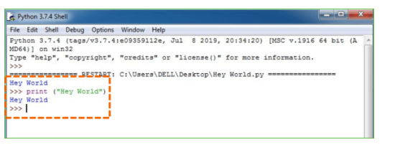

# What is Python :-

Below are some Python-related facts.

Python is currently the most popular high-level, general-purpose programming language.

Python supports both Object-Oriented and Procedural programming paradigms. Python programmers are typically smaller than those written in languages such as Java.

Programmers must type relatively less, and the language's indentation requirement ensures that their code is always readable.

Python is utilized by the majority of digital giants, like Google, Amazon, Facebook, Instagram, Dropbox, Uber, etc.

Python's greatest strength is its extensive standard library, which may be used for the following:

• Automatic Learning

• GUI Programming (like Kivy, Tkinter, PyQt etc. )

• Web frameworks like Django (used by YouTube, Instagram, Dropbox)

• Image processing (like OpenCV, Pillow)

• Web harvesting (like Scrapy, BeautifulSoup, Selenium)

• Test structures

• Multimedia

### **Advantages of Python**: -

### Let's take a look at how Python stacks up against the competition. Libraries with a lot of content Regular expressions, documentation generation, unit testing, web browsers, threading, databases and CGI are just a few of the many features that Python comes with in the form of a large library that may be used in a variety of ways. As a result, writing the entire code for that automatically isn't necessary.

**Adaptable**

Python may be expanded to work with other languages, as we saw earlier. Some of your code can be written in languages like C++ or C. For projects, this is very useful.

**Embed-able**

Python's extensibility and embeddability go hand in hand. Python code can be included into source code written in a different programming language, such as C++. This allows us to incorporate scripting into our code written in a different language.

**The Ability to Work Longer and Harder**

The language's ease of use and vast library make it more productive for programmers than Java or C++ are. Also, you should write less and accomplish more.

**5. Possibilities for IoT**

The Internet of Things has a bright future since Python is the foundation of emerging platforms such as Raspberry Pi. This is a technique of bringing the language into contact with the outside world.

**6. It's Quick and Easy to Use**

Java users may find themselves having to write their own "Hello World" class. However, in Python, a simple print statement is all that is needed. It's also a breeze to pick up, comprehend, and use. People find it difficult to learn other, more verbose languages like Java after learning Python.

**7. It's easy to read**

You can read Python just like you would read English because of its simplicity. This is why it is so simple to learn, comprehend, and code. Block definitions do not require curly brackets, and indentation is required. Code readability is aided by this further.

**Object-Oriented Programming (OO)**

Procedural and object-oriented programming paradigms can both be implemented in this language. Classes and objects, on the other hand, allow us to model the real world. Encapsulation of data and functions into a single class is made possible by a class. Open-source and free.According to our preceding discussion on Python, it is available for free. Python can be downloaded for free, and the source code can be downloaded, modified, and even distributed. It comes preloaded with a plethora of useful libraries that you can use to speed up your work.

**Portable**

If you write your project in C++, you may have to make some modifications if you want to execute it on a different operating system. It's different with Python. With this platform, you only have to write code once and then use it anywhere. This is referred to as "Write Once, Run Anywhere" (WORA). You must, however, exercise caution so as not to add any features that are dependent on the target system. Interpretation of number eleven For the record, it is an interpreted dialect. Debugging is simpler than in compiled languages since each statement is executed sequentially.

Do you still have any reservations about Python's advantages? Make a remark in the section for that The Benefits of Using Python Instead of Other Languages

1. Reduced coding

Almost all jobs may be accomplished with less coding in Python than in other programming languages. It is not necessary to use any third-party libraries with Python's excellent standard library support. This is why so many people recommend that newcomers take up Python.

2. Reasonably priced

Due to the fact that Python is open-source, anyone, from startups to multinational corporations, can take advantage of the free tools and resources it makes available. If you're looking for a community to help you out, Python is the way to go.

Python can be run on a Linux, Mac, or Windows computer. Python allows you to construct web apps, perform data analysis and machine learning, automate tasks, scrape the web, and create games and stunning visualisations with ease, all in one language. A versatile programming language, it may be used for any task.

So far, we've seen a number of reasons why Python is an excellent choice. However, if you decide to go this route, you should be informed of the ramifications. Consider now the drawbacks of using Python rather than another programming language.

Limits on the Maximum Speed

Line-by-line execution of Python code has been shown. However, because Python is an interpreted language, slowness is a common problem. It's not an issue unless the project's primary focus is on speed. If fast speed is not absolutely necessary, then Python's advantages more than make up for its drawbacks in this regard.

Not strong enough when it comes to mobile computing and browsing

As a server-side language, Python is wonderful, but it is rarely used on the client-side. Furthermore, it is rarely utilised to implement applications for smartphones. Carbonnelle is one such programme.

Due to the fact that Brython exists, it isn't as well-known as it should be.

Restrictions on Design

Python, as you know, is a dynamically typed language. It is not necessary to define the type of a variable at runtime. Duck-typing is employed in this instance. Then what's that I hear? It simply means that everything that resembles a duck must be one. Even though this makes coding easier for programmers, it might lead to run-time mistakes.

Inadequately designed database access methods.

As compared to JDBC (Java DataBase Connectivity) and ODBC (Open DataBase Connectivity), Python's database access layers are less established. As a result, it is less frequently used in large corporations.

5. This is the simplest of the bunch.

No, we're not making this up. Python's brevity can be a drawback. Take what I've just said as an example.

Rather than Java, I'm a fan of Python. To my mind, its syntax is so basic that the verbosity of Java code seems needless.

In this article, we looked at Python's benefits and drawbacks as a programming language.

**History of Python: -**

What is the connection between the alphabet and Python? Yes, both begin with the letters ABC. In the Python context, it's apparent that ABC programming language is being referred to. Developed in Amsterdam, the Netherlands, at the CWI, ABC is a general-purpose programming language and environment (Centrum Wiskunde & Informatica). ABC's largest contribution was to Python's design. As far back as the 1980s, Python was being considered for use as an open-source programming language. A distributed operating system dubbed Amoeba was being worked on by Guido van Rossum at the CWI at the time. Guido van Rossum noted in an interview with Bill Venners1: "At Centrum voor Wiskunde en Informatica in the early 1980s, I worked as an implementer on a team developing a language called ABC (CWI). What do you know about ABC's impact on Python? I make an effort to acknowledge ABC's influence since I owe so much to the folks who worked on that project and taught me so much." Van Rossum went on to say later in the interview: "All of my memories and some of my frustrations with ABC came flooding back to me. I set out to create a scripting language that had some of the advantages of ABC but none of its drawbacks. So I began to type away. Simple virtual machines and parsers were all that was needed to get the job done. I reworked some of the portions of the ABC that appealed to me. In the beginning, I designed a simple syntax, employed indentation for statement grouping instead of curly brackets or begin-end blocks, and developed a small number of powerful data types: a hash table (or dictionary, as we call it), a list, strings and numbers."

**What is Machine Learning : -**

A basic understanding of machine learning is necessary before delving into the specifics of various methods. It's common to think of machine learning as a subsection of artificial intelligence, but I find such categorization to be deceptive at first blush. To understand machine learning, it's important to think of it as a way to generate models from datasets rather than as a study of machine learning in its own right.

Building mathematical models to better comprehend data is at the heart of machine learning. In order to consider a programme to be "learning" from data, we must offer these models configurable parameters that can be adjusted in response to observed data. These models can be used to predict and interpret characteristics of new data once they have been fit to previously observed data. As for the philosophical question of whether this form of mathematical, model-based "learning" is in any way like human brain "learning," I'm going to leave it up to the reader to decide for themselves. We'll begin our discussion of machine learning with some general categorizations of the methodologies we'll examine.

**Categories Of Machine Leaning :-**



Supervised learning and unsupervised learning are the two most basic types of machine learning. It is possible to apply labels to previously unknown data using supervised learning, which entails modelling the link between data features that can be assessed and a label that is associated with the data. In classification, the labels are discrete categories, but in regression, the labels are continuous values. This is further classified into the following tasks: In the next section, we'll look at some real-world instances of both types of supervised learning.

As the term "letting the dataset speak for itself" suggests, unsupervised learning entails creating models of dataset features without using any labels. Tasks like clustering and dimensionality reduction are included in these models. Dimensionality reduction methods look for more concise representations of the data whereas clustering algorithms look for discrete groups of data. In the next part, we'll see instances of both types of unsupervised learning. Machine Learning is a must.

Humans are currently the most intelligent and advanced species on the planet, able to reason, evaluate, and come up with solutions to even the most difficult issues. The opposite is also true: Artificial intelligence (AI) is still in its infancy and hasn't yet overtaken human intelligence in many areas as well. The next logical question is: Why bother having a computer learn anything at all? "To make decisions, based on data, with efficiency and scalability" is the most appropriate rationale for doing this.

Newer technologies like Artificial Intelligence, Machine Learning and Deep Learning are being heavily invested in by corporations in recent years in order to extract the most relevant information from large amounts of data and address real-world problems. The term "data-driven decisions" can be used to describe these decisions made by computers, especially in the context of automating the process. The use of data-driven judgments instead of programming logic can be utilised to solve problems that cannot be coded from the start. We can't live without human intelligence, but we also need to tackle real-world problems efficiently and on a large scale, and that's a fact. That's why machine learning is necessary.

**Robotics and Artificial Intelligence**

While Machine Learning is making great progress in cybersecurity and autonomous vehicles, this section of AI as a whole still has a long road ahead of it. Since ML hasn't had much success, this is the main reason. In the present, ML is faced with the following difficulties:

One of the most difficult aspects of machine learning (ML) is obtaining high-quality data. Data preprocessing and feature extraction are complicated when low-quality data is used.

Data collection, feature extraction, and feature retrieval are all time-consuming tasks for machine learning models.

As ML technology is still in its infancy stage, it is difficult to find experts in the field.

As ML continues to evolve, it faces the additional obstacle of not having a clearly defined purpose and well-defined goal when formulating business problems.

## A model's ability to accurately depict a situation is compromised if it is either overly or underly fitted.

## The curse of dimensionality is a problem that ML models must contend with since there are simply too many features in the data. As a result, it's not uncommon for this to be an issue.

## Complexity of the ML model impedes its ability to be used in the actual world.

**Purpose: -**

We demonstrated that our approach enables successful segmentation of intra-retinal layers—even with low-quality images containing speckle noise, low contrast, and different intensity ranges throughout—with the assistance of the ANIS feature.

**Python**

An interpretive high-level programming language for general-purpose applications, Python was created by Guido van Rossum. Developed by Guido van Rossum, Python has a focus on code readability and makes extensive use of whitespace. It was initially released in 1991.

An autonomous memory management system and a dynamic type system distinguish Python from other programming languages. One of the most popular programming languages, it contains an extensive standard library that enables a wide range of programming styles.

This means that Python is digested by the interpreter as it runs. Compiling your software is not required before running it. PERL and PHP are both examples of this.

When you sit down at a Python prompt and engage with the interpreter, you can actually write your programmers in an interactive way.

As a result, Python recognizes the importance of rapid development. Access to strong structures that avoid repetitive repetition of code is one way to achieve readable and pithy code. When it comes to troubleshooting issues or fine-tuning behavior, the amount of code you have to scan, read, and/or understand has some bearing on maintainability. Another area in which Python shines is in its rapid development, the simplicity with which a programmer of another language can pick up the basics of Python, and the enormous standard library. Everything about it was quick to implement, saving a lot of time, and some of its tools have since been modified by non-Python programmers without causing any problems.

**Modules Used in Project :-**

**Tensorflow**

Open-source dataflow and differentiable programming framework TensorFlow is available for a wide range of activities. For machine learning applications like neural networks, it is a symbolic math library. Research and development use it as well as production.

Developed by Google's Brain team, TensorFlow is used internally by Google. On November 9th, 2015, it was made available under the Apache 2.0 open-source licence..

**Numpy**

A general-purpose array-processing toolkit, Numpy is available. High-performance multidimensional array objects and tools for interacting with these arrays are provided.

It is a must-have package for Python scientists. It has a number of key features, including these ones:a potent array object with N dimensions

Aesthetics and technical aspects of broadcasting

Linear algebra, Fourier transforms, and random number generators are all included in these tools.

Numpy can also be used as an efficient multi-dimensional container of generic data, in addition to its apparent scientific applications. Numpy enables for the definition of any data types, making it compatible with a wide range of databases in an easy and quick manner.

**Pandas**

Pandas is an open-source Python library that provides strong data structures for data manipulation and analysis. Python was primarily utilised for data manipulation and prepping. It made a tiny dent in the data analysis process. This was a problem that Pandas solved. Data processing and analysis typically involves five steps: load, prepare, modify, model, and analyse, all of which may be accomplished with Pandas. Python and Pandas are widely utilised in a variety of sectors, including finance, economics, statistics, and analytic applications..

**Matplotlib**

Mathematica's Matplotlib is a Python 2D plotting toolkit that produces publication-quality figures in a wide range of hardcopy formats and interactive settings across platforms. In Python scripts, the Python and IPython shells, the Jupyter Notebooks, web application servers, and four graphical user interface toolkits, Matplotlib can be utilised.

Matplotlib aims to make simple tasks simple and difficult tasks doable. Plots, histograms, power spectra, bar graphs, error graphs, scatter plots, and other visualisations can be generated with as few as a few lines of code. See the sample plots and the thumbnail galleries for examples.

With IPython, the pyplot module provides a familiar MATLAB-like interface for easy graphing. The power user has full control over line styles, font settings, axis properties, etc., using an object-oriented interface or a set of methods known to MATLAB users.

**Scikit – learn**

Scikit-learn provides a standard Python interface for a variety of supervised and unsupervised learning techniques. It is licenced under a BSD-style licence that allows for both academic and commercial use, and is available on a variety of Linux versions. Python

An interpretive high-level programming language for general-purpose applications, Python was created by Guido van Rossum. Developed by Guido van Rossum, Python has a focus on code readability and makes extensive use of whitespace. It was initially released in 1991.

An autonomous memory management system and a dynamic type system distinguish Python from other programming languages. One of the most popular programming languages, it contains an extensive standard library that enables a wide range of programming styles.

This means that Python is digested by the interpreter as it runs. Compiling your software is not required before running it. PERL and PHP are both examples of this.

When you sit down at a Python prompt and engage with the interpreter, you can actually write your programmers in an interactive way.

As a result, Python recognizes the importance of rapid development. Access to strong structures that avoid repetitive repetition of code is one way to achieve readable and pithy code. When it comes to troubleshooting issues or fine-tuning behavior, the amount of code you have to scan, read, and/or understand has some bearing on maintainability. Another area in which Python shines is in its rapid development, the simplicity with which a programmer of another language can pick up the basics of Python, and the enormous standard library. Everything about it was quick to implement, saving a lot of time, and some of its tools have since been modified by non-Python programmers without causing any problems.

**Install Python Step-by-Step in Windows and Mac: -**

Because it is so versatile, Python is not pre-installed on most computers. As of now, Python is one of the most widely used high-level programming languages. Because of its prominent use of significant whitespace, its design philosophy places an emphasis on code readability.

It is possible to develop straightforward and logical code with Python because of the object-oriented approach and the language constructs. Windows does not come pre-installed with this application.

Installing Python on a PC or a Mac:

Python has seen a number of changes throughout the years. Installing Python is a bit of a mystery. If you're just release of Python, which is also known as Python 3.

Python 3.7.4 is not compatible with Windows XP or previous operating systems.

To begin with, you will need to download Python and run the setup programme. To begin, learn about your computer's minimum system requirements. You must download the python version that is appropriate for your operating system and processor. Windows 64-bit is the operating system I'm using. Installing Python 3.7.4 or Python 3 on a Windows 7 computer is as simple as following the instructions below. Here is a link

to the Python Cheat Sheet. In order to make things easier to follow, we've broken down the Python installation process into four sections.

### **Download the Correct version into the system**

**Step 1:** Go to the official site to download and install python using Google Chrome or any other web browser. OR Click on the following link: [**https://www.python.org**](https://www.python.org/)



Now, check for the latest and the correct version for your operating system.

**Step 2:** Click on the Download Tab.



**Step 3:** You can either select the Download Python for windows 3.7.4 button in Yellow Color or you can scroll further down and click on download with respective to their version. Here, we are downloading the most recent python version for windows 3.7.4



**Step 4:** Scroll down the page until you find the Files option.

**Step 5:** Here you see a different version of python along with the operating system.





A Windows 32-bit Python executable, embeddable zip file, or web-based installer can all be used to obtain the latest version of Python on your system.

There are three ways to get Windows 64-bit Python: the Windows x86-64 embeddable zip file, the Windows x86-64 executable installer, or the Windows x64 web-based installer.

The web-based installer for Windows x86-64 will be set up here. The first portion of your question about which Python version should be downloaded is now answered. The next step in the installation of Python is to do the following: Installation

Use the Release Notes option to learn about the changes or updates made in this version.

The first step is to install Python. Start by downloading Python and then opening it to begin the installation process.



**Step 2:** Before you click on Install Now, Make sure to put a tick on Add Python 3.7 to PATH.

**Step 3:** Click on Install NOW After the installation is successful. Click on Close.



With these above three steps on python installation, you have successfully and correctly installed Python. Now is the time to verify the installation.

**Note:** The installation process might take a couple of minutes.

### **Verify the Python Installation**

**Step 1:** Click on Start

**Step 2:** In the Windows Run Command, type “cmd”



**Step 3:** Open the Command prompt option.

**Step 4:** Let us test whether the python is correctly installed. Type **python –V** and press Enter.





**Step 5:** You will get the answer as 3.7.4

**Note*:*** If you have any of the earlier versions of Python already installed. You must first uninstall the earlier version and then install the new one.

### **Check how the Python IDLE works**

**Step 1:** Click on Start

**Step 2:** In the Windows Run command, type “python idle”



**Step 3:** Click on IDLE (Python 3.7 64-bit) and launch the program

**Step 4:** To go ahead with working in IDLE you must first save the file. **Click on File > Click on Save**





**Step 5:** Name the file and save as type should be Python files. Click on SAVE. Here I have named the files as Hey World.

**Step 6:** Now for e.g. **enter print (“Hey World”)** and Press Enter.



As soon as you give an order, it will be executed. This concludes our look at how to set up Python. You've now learned how to install python on your Windows computer.

It's important to note that unlike Java, Python doesn't require semicolons at the conclusion of statements the world is included in this stack.

Django – Principles of Design

Django's design philosophy is based on the following:

Django's stack is designed to be loosely coupled, allowing each component to stand on its own.

• Less Coding Because there is less code, the project can be developed faster.

• Don't Repeat Yourself (DRY) — Everything should be developed once and not repeated over and over.

It's Django's goal to make it possible for developers to work quickly and efficiently.

Clean Design – Django maintains a clean design across its own code and makes it easier to follow top web-development practices. There are several advantages of using Django

Django has a number of advantages that can be outlined here.

With Django's Object-Relational Mapping (ORM) support, you can connect your database to your data model, which includes MySQL, Oracle, Postgres, and more. Django-nonreal is a clone of Django that provides support for NoSQL databases. NoSQL databases are currently only supported by MongoDB and Google's App Engine service.

Django's integrated internationalization system makes it possible to run multilingual websites. As a result, you can create a website that is multilingual. Ajax, RSS, Caching, and other frameworks are all supported by Django out of the box.

When it comes to administrative tasks, Django provides a clean and intuitive UI. Development Tools & Resources. End-to-end application development and testing are made easier with Django's built-in lightweight web server.

Django is a Python-based web framework. Django also supports the MVC design pattern, which is common in most modern frameworks. Model-View-Template (MVT) is a variation of the Model-View-Controller (MVC) design that is exclusive to Django.

Model-View-Controller Architecture

MVC design is commonly used when discussing web or desktop applications that provide a user interface (UX)... Model, View, and Controller are all components of the MVC paradigm, as its name suggests. For additional information, see our MVC tutorial.

In Django, the MVT pattern is used in the MVC framework

There are some differences between MVT and MVC. Django, on the other hand, takes care of the Controller (the software code that regulates the interactions between the Model and View) and leaves us with the template. Django Template Language (DTL) is incorporated into the HTML file (DTL).

The following diagram shows how the MVT pattern's various components work together to fulfil a user request.

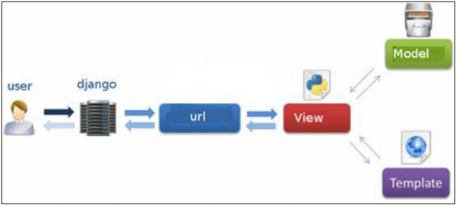

**Fig 2.2: Django MVC – MVT Pattern**

The developer provides the Model, the view and the template then just maps it to a URL and Django does the magic to serve it to the user.

**4.7 Jupyter Notebook**

Using the Jupyter Notebook, you may create and share documents with live code, equations, visualizations and text. The Jupyter Notebook is an open-source web application. Project Jupyter maintains the Jupyter Notebook.

In fact, Jupyter Notebooks are an offshoot of the IPython project, which had its own version of the IPython Notebook. Because it supports Julia, Python, and R, the name "Jupyter" is a play on those three programming languages. In addition to the IPython kernel that ships with Jupyter, there are currently over 100 different kernels that you can use to develop your Python programmers.

**4.8 Anaconda: -**

What kind of Python is Anaconda?

Together with a list of Python packages, utilities like editors, Python distributions contain the Python interpreter. Anaconda is one of several Python distributions. Python and R data research package Anaconda is a new distribution of Anaconda. Continuum Analytics was the previous name of the company. More than 100 new packages have been added to Anaconda.

Scientists and statisticians use Anaconda to do computationally intensive tasks like data mining and machine learning. Anaconda 5.0.1 was published in October 2017 as the newest version.

The newly released version 5.0.1 fixes a few niggling flaws and includes some nice new capabilities, like support for the R programming language. The initial 5.0.0 release didn't have any of these features.

This package manager is also an environment manager, a Python distribution, and a collection of open-source packages and contains more than 1000 R and Python Data Science Packages.

What is Anaconda's advantage over other Python IDEs?

Switching to Anaconda isn't necessary if you're content with your current Python installation. But some people like data scientists who are not full-time developers, find anaconda considerably valuable as it simplifies a lot of frequent problems a newbie goes into.

Anaconda can help with – \s• Installing Python on multiple platforms

Identifying and categorising various environments

Dealing with not having proper privileges and getting required packages and libraries up and running

Where can I get Anaconda 5.0.1 from?

**CHAPTER 5**

**CODING**

**CODING**:

**Python: -**

from flask import Flask, render_template, jsonify, request, Markup

from jinja2 import Environment, FileSystemLoader

import numpy as np

import os, re, glob, sys

from tensorflow.keras.models import load_model

from tensorflow.keras.preprocessing import image

from werkzeug.utils import secure_filename

import time

import cv2

app = Flask(__name__)

model = load_model('Models/model.h5')

#model.make_prediction()

def model_predict(img_path, model):

start = time.time()

print(img_path)

img = image.load_img(img_path, target_size=(224, 224))

print(f'load_image took {time.time()-start}')

# Preprocessing the image

x = image.img_to_array(img)

# x = np.true_divide(x, 255)

## Scaling

x=x/255

x = np.expand_dims(x, axis=0)

print(f'x took {time.time()-start}')

# Be careful how your trained model deals with the input

# otherwise, it won't make correct prediction!

# x = preprocess_input(x)

preds = model.predict(x)

#model.make_predict_function

print(f'model predict took {time.time()-start}')

preds=np.argmax(preds, axis=1)

if preds==0:

preds="rich"

elif preds==1:

preds="middle."

elif preds==2:

preds="poor"

else:

preds="invalid"

#time.sleep(1)

end = time.time()

print(f"Runtime model of the program is {end - start}")

return preds

@app.route('/', methods=['GET'])

def home():

start = time.time()

time.sleep(1)

end = time.time()

print(f"Runtime home of the program is {end - start}")

return render_template('index.html')

@app.route('/predict', methods=['GET', 'POST'])

def predict():

if request.method == 'POST':

# Get the file from post request

f = request.files['file']

# Save the file to ./uploads

start = time.time()

basepath = os.path.dirname(__file__)

file_path = os.path.join(

basepath, 'uploads', secure_filename(f.filename))

f.save(file_path)

print(f'saving file took {time.time()-start}')

# Make prediction

preds = model_predict(file_path, model)

result=preds

#time.sleep(1)

end = time.time()

print(f"Runtime predict of the program is {end - start}")

return render_template('display.html',result= result)

if __name__ == "__main__":

#app.run(debug=True)

app.run(host="127.0.0.1", port=5000, threaded=True)

**HTML: -**

**Home Page**

<!DOCTYPE html>

<html>

<head>

<title>Poverty Prediction</title>

<!--meta tags -->

<meta charset="UTF-8">

<meta name="viewport" content="width=device-width, initial-scale=1">

<!--//meta tags ends here-->

<!--booststrap-->

<link rel="stylesheet" href="https://maxcdn.bootstrapcdn.com/bootstrap/4.0.0/css/bootstrap.min.css"

integrity="sha384-Gn5384xqQ1aoWXA+058RXPxPg6fy4IWvTNh0E263XmFcJlSAwiGgFAW/dAiS6JXm" crossorigin="anonymous">

<!--//booststrap end-->

<!-- font-awesome icons -->

<link rel="stylesheet" href="https://cdnjs.cloudflare.com/ajax/libs/font-awesome/4.7.0/css/font-awesome.min.css"

integrity="sha512-SfTiTlX6kk+qitfevl/7LibUOeJWlt9rbyDn92a1DqWOw9vWG2MFoays0sgObmWazO5BQPiFucnnEAjpAB+/Sw=="

crossorigin="anonymous" />

<!-- //font-awesome icons -->

<!--stylesheets-->

<link href="../static/styles/style.css" rel='stylesheet' type='text/css' media="all">

<!--//stylesheets-->

</head>

<body>

<!--headder-->

<div class="header-outs inner_page-banner" id="home">

<div class="headder-top">

<!-- nav -->

<nav>

<div id="logo">

<h1><a href="/">Predicting Poverty Levels</a></h1>

</div>

</nav>

<!-- //nav -->

</div>

</div>

<!--//headder-->

<!-- short -->

<div class="using-border py-3">

<div class="inner_breadcrumb ml-4">

<ul class="short_ls">

<li>

<a href="/">Home</a>

</ul>

</div>

</div>

<!-- //short-->

<!-- about -->

<section class="about py-lg-4 py-md-3 py-sm-3 py-3" id="about">

<div class="container py-lg-5 py-md-4 py-sm-4 py-3">

<div class="row" style="justify-content: center;">

<div class="col-md-10 about-two-grids">

<h3 class="mb-md-4 mb-sm-3 mb-3 text-center">Result</h3>

<div class="about-para-txt text-justify">

<h3 class="mb-md-4 mb-sm-3 mb-3 text-center" style="font-size: xx-large; font-family: 'Times New Roman', Times, serif;">

{{result}}

</h3>

</div>

</div>

</div>

</div>

</section>

<!-- //about -->

<!-- footer -->

<script src="https://code.jquery.com/jquery-3.2.1.slim.min.js"

integrity="sha384-KJ3o2DKtIkvYIK3UENzmM7KCkRr/rE9/Qpg6aAZGJwFDMVNA/GpGFF93hXpG5KkN"

crossorigin="anonymous"></script>

<script src="https://cdnjs.cloudflare.com/ajax/libs/popper.js/1.12.9/umd/popper.min.js"

integrity="sha384-ApNbgh9B+Y1QKtv3Rn7W3mgPxhU9K/ScQsAP7hUibX39j7fakFPskvXusvfa0b4Q"

crossorigin="anonymous"></script>

<script src="https://maxcdn.bootstrapcdn.com/bootstrap/4.0.0/js/bootstrap.min.js"

integrity="sha384-JZR6Spejh4U02d8jOt6vLEHfe/JQGiRRSQQxSfFWpi1MquVdAyjUar5+76PVCmYl"

crossorigin="anonymous"></script>

</body>

</html>

**Result Page:-**

<!DOCTYPE html>

<html>

<head>

<title>Poverty Prediction</title>

<!--meta tags -->

<meta charset="UTF-8">

<meta name="viewport" content="width=device-width, initial-scale=1">

<!--//meta tags ends here-->

<!--booststrap-->

<link rel="stylesheet" href="https://maxcdn.bootstrapcdn.com/bootstrap/4.0.0/css/bootstrap.min.css"

integrity="sha384-Gn5384xqQ1aoWXA+058RXPxPg6fy4IWvTNh0E263XmFcJlSAwiGgFAW/dAiS6JXm" crossorigin="anonymous">

<!--//booststrap end-->

<!-- font-awesome icons -->

<link rel="stylesheet" href="https://cdnjs.cloudflare.com/ajax/libs/font-awesome/4.7.0/css/font-awesome.min.css"

integrity="sha512-SfTiTlX6kk+qitfevl/7LibUOeJWlt9rbyDn92a1DqWOw9vWG2MFoays0sgObmWazO5BQPiFucnnEAjpAB+/Sw=="

crossorigin="anonymous" />

<!-- //font-awesome icons -->

<!--stylesheets-->

<link href="../static/styles/style.css" rel='stylesheet' type='text/css' media="all">

<!--//stylesheets-->

</head>

<body >

<div class="main-top" id="home">

<!-- header -->

<div class="headder-top">

<!-- nav -->

<nav>

<div id="logo">

<h1><a href="index.html">Predicting Poverty Level</a></h1>

</div>

<label for="drop" class="toggle">Menu</label>

<input type="checkbox" id="drop">

<ul class="menu mt-2">

<li class="active"><a href="#home">Home</a></li>

<li><a href="#about">About</a></li>

<li><a href="#test">Detect</a></li>

</ul>

</nav>

<!-- //nav -->

</div>

<!-- //header -->

<!-- banner -->

<div class="main-banner text-center">

<div class="container">

<div class="style-banner">

<h5 class="mb-2">Welcome To Poverty Prediction</h5>

</div>

<div class="two-demo-button mt-md-4 mt-3">

</div>

</div>

</div>

</div>

<!-- //banner -->

<!-- about -->

<section class="about py-lg-4 py-md-3 py-sm-3 py-3" id="about">

<div class="container py-lg-5 py-md-4 py-sm-4 py-3">

<div class="row">

<div class="col-lg-6 about-imgs-txt pt-3">

<img src="../static/images/4.jpg" alt="news image" class="img-fluid" style="border-radius: 8px;">

</div>

<div class="col-lg-6 text-justify about-two-grids pt-3">

<h3 class="title text-center">Abstract</h3>

<div class="about-para-txt">

<p>Determining the poverty levels of various regions throughout the world is crucial in identifying interventions for poverty reduction initiatives and directing resources fairly. However, reliable data on global economic livelihoods is hard to come by, especially for areas in the developing world, hampering efforts to both deploy services and monitor/evaluate progress. This project proposes to use satellite images to detect economic activity and, as a result, estimate poverty in a location. Here we use Image Sensing. A Recurrent neural network is trained to learn various developmental parameters like rooftop type, source of lighting and proximity to water sources, Agriculture Areas, Road Structure and Industrial Areas. </p>

</div>

</div>

</div>

</div>

</section>

<!-- //about -->

<!-- service -->

<!--section class="service pb-5 " id="features">

<div class="container ">

<h3 class="title text-center mb-3">Features</h3>

<div class="row">

<div class="col-lg-4 col-md-6 col-sm-6 mt-lg-4 mt-3 service-grid-wthree text-center">

<div class="ser-Agriculture-grid">

<div class="about-icon mb-md-4 mb-3">

<span class="fa fa-viadeo" aria-hidden="true"></span>

</div>

<div class="ser-sevice-grid">

<h4 class="pb-3">Easy Detection</h4>

<p>Just need to click and upload leaf image.</p>

</div>

</div>

</div>

<div class="col-lg-4 col-md-6 col-sm-6 mt-lg-4 mt-3 service-grid-wthree text-center">

<div class="ser-Agriculture-grid">

<div class="about-icon mb-md-4 mb-3">

<span class="fa fa-pagelines" aria-hidden="true"></span>

</div>

<div class="ser-sevice-grid">

<h4 class="pb-3">Cause and Solution</h4>

<p>Provides the cause and solution of the identified Hearbal Plant.</p>

</div>

</div>

</div>

<div class="col-lg-4 col-md-6 col-sm-6 mt-lg-4 mt-3 service-grid-wthree text-center">

<div class="ser-Agriculture-grid">

<div class="about-icon mb-md-4 mb-3">

<span class="fa fa-leaf" aria-hidden="true"></span>

</div>

<div class="ser-sevice-grid">

<h4 class="pb-3">Large Plant Support</h4>

<p>Supports different types of plants.</p>

</div>

</div>

</div>

</div>

</div>

</section -->

<section class="blog_w3ls py-3 pb-5 pt-10" id="test">

<div class="container pb-xl-5 pb-lg-3">

<h3 class="title text-center mb-lg-5 mb-md-4 mb-sm-4 mb-3"> Test Your Area</h3>

<div class="row" style="justify-content: center;">

<form action="{{ url_for('predict') }}" method="POST" enctype=multipart/form-data>

<div class="form-group text-center">

<label for="exampleFormControlFile1"><b>Input a file</b></label>

<input type="file" name="file" class="form-control-file" id="inputImage" onchange=previewImage(event)

required>

<br />

<button class="btn btn-primary" type="submit"> Predict </button>

</div>

</form>

</div>

<img id="output-image" class="rounded mx-auto d-block" />

<br />

</div>

</section>

<!--//footer -->

<script src="https://code.jquery.com/jquery-3.2.1.slim.min.js"

integrity="sha384-KJ3o2DKtIkvYIK3UENzmM7KCkRr/rE9/Qpg6aAZGJwFDMVNA/GpGFF93hXpG5KkN"

crossorigin="anonymous"></script>

<script src="https://cdnjs.cloudflare.com/ajax/libs/popper.js/1.12.9/umd/popper.min.js"

integrity="sha384-ApNbgh9B+Y1QKtv3Rn7W3mgPxhU9K/ScQsAP7hUibX39j7fakFPskvXusvfa0b4Q"

crossorigin="anonymous"></script>

<script src="https://maxcdn.bootstrapcdn.com/bootstrap/4.0.0/js/bootstrap.min.js"

integrity="sha384-JZR6Spejh4U02d8jOt6vLEHfe/JQGiRRSQQxSfFWpi1MquVdAyjUar5+76PVCmYl"

crossorigin="anonymous"></script>

<script>

function previewImage(event) {

var reader = new FileReader();

reader.onload = function () {

var output = document.getElementById('output-image')

output.src = reader.result;

}

reader.readAsDataURL(event.target.files[0]);

}

</script>

</body>

</html>

**CHAPTER 6**

**TESTING**

**Testing**

**SYSTEM TESTING**

The purpose of testing is to discover errors. Testing is the process of trying to discover every conceivable fault or weakness in a work product. It provides a way to check the functionality of components, subassemblies, assemblies and/or a finished product It is the process of exercising software with the intent of ensuring that the Software system meets its requirements and user expectations and does not fail in an unacceptable manner. There are various types of test. Each test type addresses a specific testing requirement.

# 6.1 TYPES OF TESTS

**Unit testing**

Unit testing involves the design of test cases that validate that the internal program logic is functioning properly, and that program inputs produce valid outputs. All decision branches and internal code flow should be validated. It is the testing of individual software units of the application. It is done after the completion of an individual unit before integration. This is a structural testing, that relies on knowledge of its construction and is invasive. Unit tests perform basic tests at component level and test a specific business process, application, and/or system configuration. Unit tests ensure that each unique path of a business process performs accurately to the documented specifications and contains clearly defined inputs and expected results.

# Integration testing

Integration tests are designed to test integrated software components to determine if they actually run as one program. Testing is event driven and is more concerned with the basic outcome of screens or fields. Integration tests demonstrate that although the components were individually satisfaction, as shown by successfully unit testing, the combination of components is correct and consistent. Integration testing is specifically aimed at exposing the problems that arise from the combination of components.

# Functional test

Functional tests provide systematic demonstrations that functions tested are available as specified by the business and technical requirements, system documentation, and user manuals.

Functional testing is centered on the following items:

Valid Input : identified classes of valid input must be accepted.

Invalid Input: identified classes of invalid input must be rejected.

Functions : identified functions must be exercised.

Output : identified classes of application outputs must be exercised. Systems/Procedures: interfacing systems or procedures must be invoked.

Organization and preparation of functional tests is focused on requirements, key functions, or special test cases. In addition, systematic coverage pertaining to identify Business process flows; data fields, predefined processes, and successive processes must be considered for testing. Before functional testing is complete, additional tests are identified and the effective value of current tests is determined.

# System Test

System testing ensures that the entire integrated software system meets requirements. It tests a configuration to ensure known and predictable results. An example of system testing is the configuration-oriented system integration test. System testing is based on process descriptions and flows, emphasizing pre-driven process links and integration points.

# White Box Testing

White Box Testing is a testing in which in which the software tester has knowledge of the inner workings, structure and language of the software, or at least its purpose. It is purpose. It is used to test areas that cannot be reached from a black box level.

# Black Box Testing

Black Box Testing is testing the software without any knowledge of the inner workings, structure or language of the module being tested. Black box tests, as most other kinds of tests, must be written from a definitive source document, such as specification or requirements document, such as specification or requirements document. It is a testing in which the software under test is treated, as a black box. You cannot―see‖ into it.The test provides inputs and responds to outputs without considering how the software works.

# 6.1.1 Unit Testing:

Unit testing is usually conducted as part of a combined code and unit test phase of the software lifecycle, although it is not uncommon for coding and unit testing to be conducted as two distinct phases.

## Test strategy and approach

Field testing will be performed manually and functional tests will be written in detail.

## Test objectives

All field entries must work properly.

Pages must be activated from the identified link.

The entry screen, messages and responses must not be delayed.

Features to be tested

Verify that the entries are of the correct format

No duplicate entries should be allowed

# 6.1.2 Integration Testing

Software integration testing is the incremental integration testing of two or more integrated software components on a single platform to produce failures caused by interface defects.

The task of the integration test is to check that components or software applications, e.g. components in a software system or – one step up – software applications at the company level – interact without error.

**Test Results:** All the test cases mentioned above passed successfully. No defects encountered.

# 6.1.3 Acceptance Testing

User Acceptance Testing is a critical phase of any project and requires significant participation by the end user. It also ensures that the system meets the functional requirements.

**Test Results:** All the test cases mentioned above passed successfully. No defects encountered.

# CHAPTER 7

# RESULTS

# Result

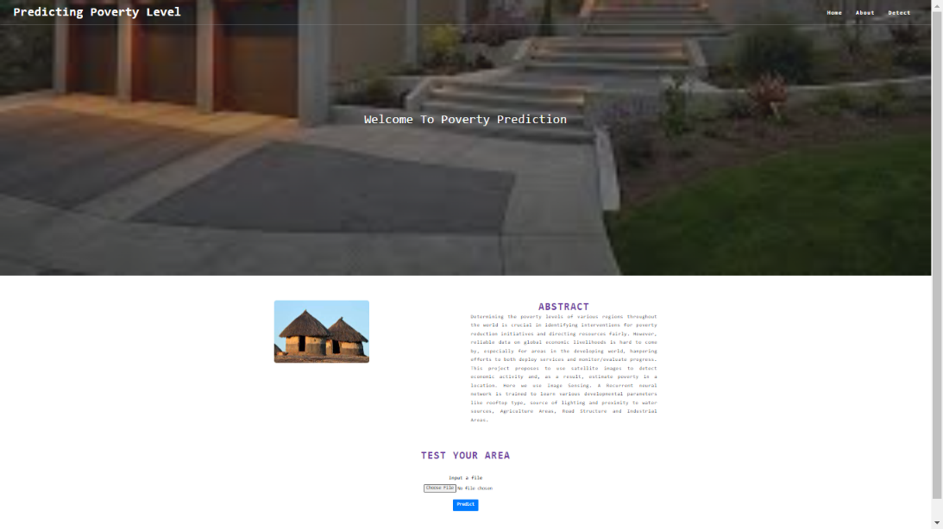

This is the home page of the website where it shows the abstract of the project which predicts the poverty level of an area.

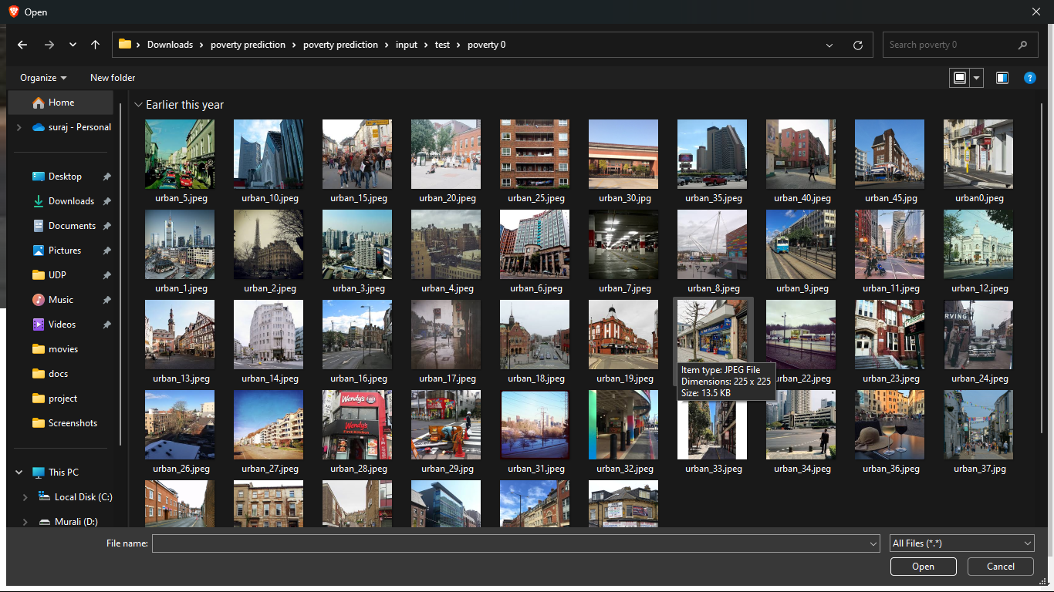

Here, we take the test data which we had trained while training the data.

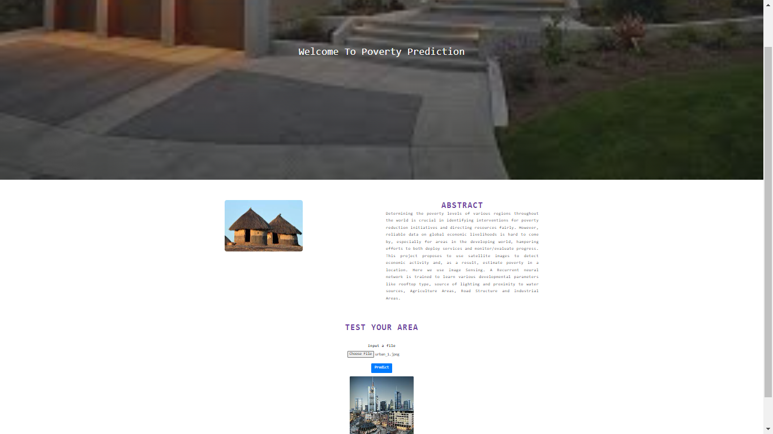

After uploading the image to the website it loads into the website. Then, click on predict button to predict the poverty levels of an area.

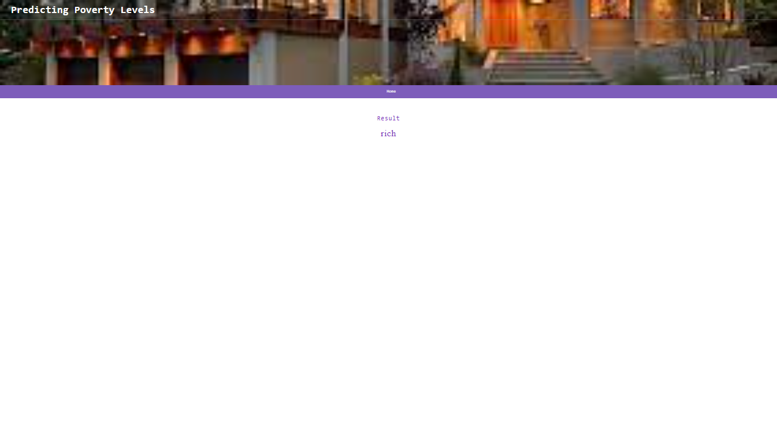

When we upload a rich side area then it predicts as a rich area. If the user needs to predict another area then the user can press on home button to navigate to the home page of the website.

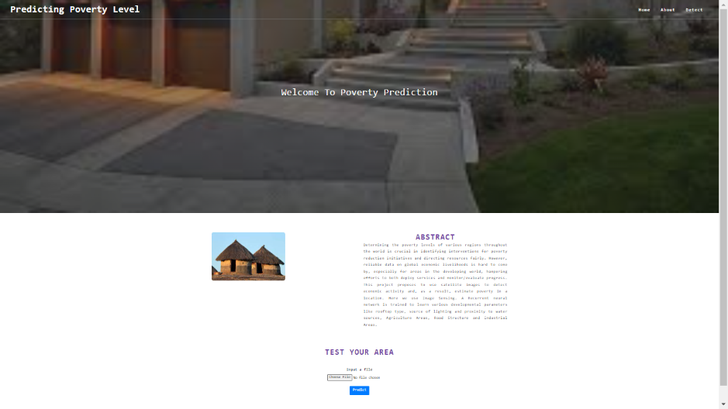

Again, the home loads and thus can upload another image into the website.

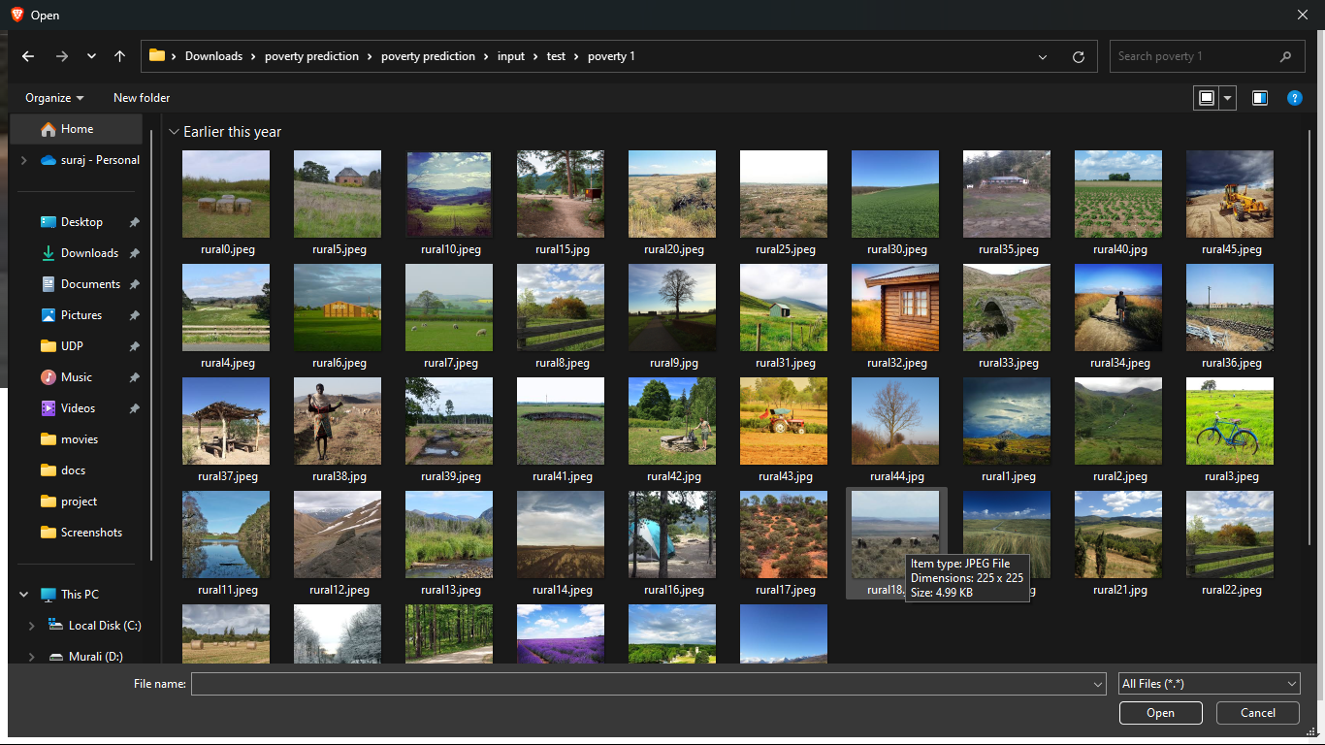

# 

# The image again loads into the website and again click on predict to predict the area.

# 

# Here, we get as the middle level city after predicting the image uploaded.

# 

# Again, the home loads and thus can upload another image into the website.

# 

# 

# The image again loads into the website and again click on predict to predict the area.

# Here, the prediction states as the poor level area.

# CHAPTER 8

**CONCLUSION**

**CONCLUSION**

Results in this paper show that the proposed method of poverty prediction using satellite data is an effective alternative to household survey and covers the limitation of time, cost and effort. Traditionally, statistical analysis on DHS data is used as a measure to predict poverty which lacks reliable and updated data. Remote sensing data is updated regularly. Nighttime satellite images are easily available from EOG of NOAA/NGDC’s DMSP-OLS satellite series and daytime satellite data available from Google static maps. Also, the advancement in machine learning algorithms for image processing makes a scope for this research. But there are some limitations of this proposed system: 1) The model trained can be used countrywide only, as there can a different relationship between light index and wealth index for different country. 2) Satellite images used in the proposed system contain some noise. Therefore there is a need to design more general model for all countries and to use advanced image processing to resolve noise.

# REFERENCES

[1] Bailang Yu et al., ―Poverty Evaluation Using NPP-VIIRS Nighttime Light Composite Data at the County Level in China‖, IEEE Journal of Selected Topics in Applied Earth Observations and Remote Sensing, vol. 8, no. 3, pp. 1217-1229, 2015.

[2] Xie, M., Jean, N., and Ermon, S. 2015. Transfer learning from deep features for remote sensing and poverty mapping. CoRR. http://arxiv.org/abs/ 1510.00098.

[3] Christopher D. Elvidge, et al.‖ Can Poverty Rates Be Estimated Using Satellite Data?‖, 2007 Urban Remote Sensing Joint Event, 2007.

[4] Shailesh M. Pandey, Tushar Agarwal and Narayanan C. Krishnan, ―Multi-Task Deep Learning for Predicting Poverty from Satellite Images‖, The Thirtieth AAAI Conference on Innovative Applications of Artificial Intelligence (IAAI-18), pp. 7793-7798.

[5] Dr. Ryan Engstrom, ―Evaluating the Relationship between Spatial and Spectral Features Derived from High Spatial Resolution Satellite Data and Urban Poverty in Colombo, Sri Lanka‖, IEEE conference of 2017 Joint Urban Remote Sensing Event.

[6] Blumenstock, J., Cadmuro, G., et al., ‖ Predicting poverty and wealth from mobile phone metadata‖. Science. 350, 6264 (Nov. 2015), 1073- 1076. DOI= 10.1126/science.aac4420.

[7]VIIRS Day/Night Band Nighttime Lights from satellite of NASA. Available online: https://ngdc.noaa.gov/eog/viirs/download_dnb_composite s.html

[8]Google Static Maps API, https://developers.google.com/maps/ documentation/static-maps/, Accessed: 2019-06-09

[9]ICF. The DHS Program. Available online: <https://dhsprogram.com/data/>

[10] JIA DENG,‖ IMAGENET: A LARGE-SCALE HIERARCHICAL IMAGE

DATABASE‖, IEEE CONFERENCE ON COMPUTER VISION AND PATTERN RECOGNITION.